**Admin Manual**

**For Ecommerce System**

**(Amazing)**

**Table of Contents**

|  |  |  |  |
| --- | --- | --- | --- |
| **1** | **OVERVIEW...............................................................................................................** | | **3** |
| **2** | **DASHBOARD ....................................................................................** | | **4** |
|  | 2.1 | To Browse the Product Catalogue ............................................................................................ | 5 |
|  | 2.2 | Register for Amazing ............................................................................................................... | 7 |
| **3** | **PRODUCTS ..............................................................** | | **8** |
|  | 3.1 | Adding items to WEBSITE ......................................................................................... | 9 |
|  | 3.2 | Editing items ................................................................................................................ | 12 |
| **4** | **ORDERS....................................................................................................** | | **13** |
|  |  |  | 14 |
| **5** | **EDIT USER PROFILE.............................................................................................** | | **15** |

**1** **OVERVIEW**

This manual provides the step-by-step user guide for the Amazing Ecommerce System (Administrator ).

Amazing Administrator website has the following features:

1. Dashboard
2. Products
3. Order Processing
   1. Online Order Status
   2. Past Orders listing for users
   3. Account information
4. Users

The address to the demo of Amazing website: <https://poochswadge-amazing.herokuapp.com/>

Amazing User Manual

**2** **Dashboard**

Administrator need has an account to access Amazing Administrator Website

The Amazing Administrator home page is shown below.

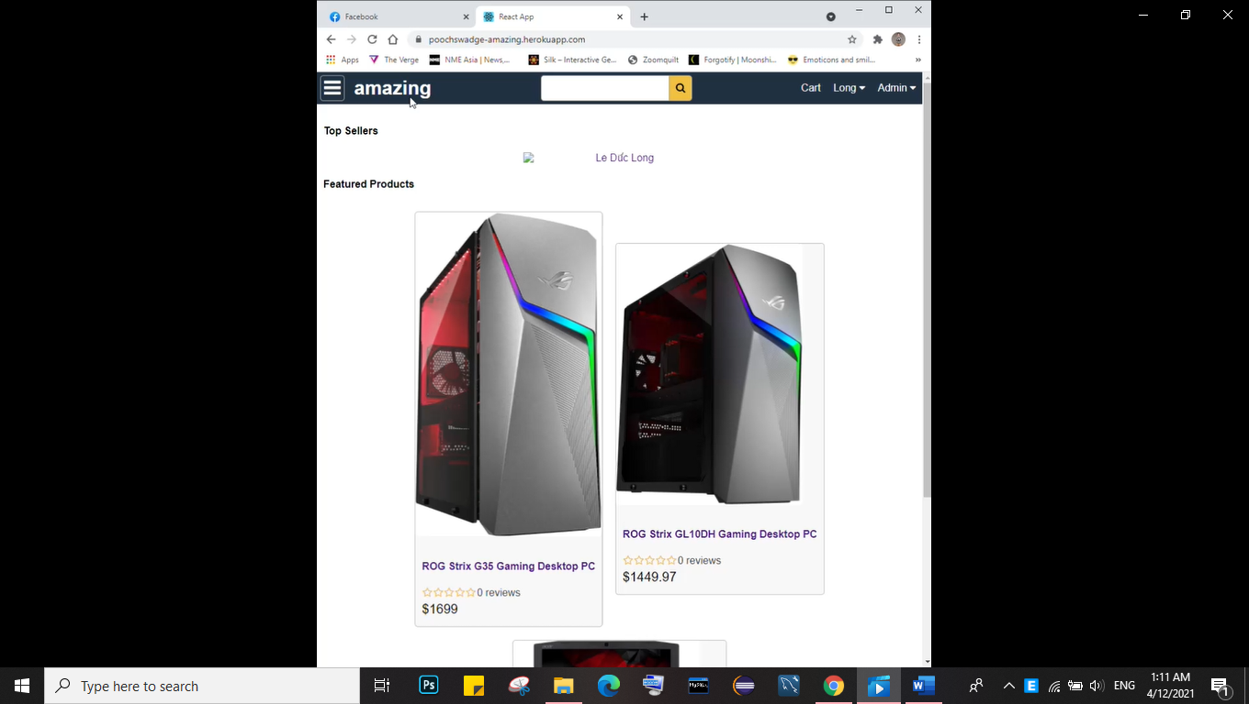

**Product Catalogue**

When you click on *Product* link will allow you to add, edit or remove for Amazing products based on any of the following criteria.

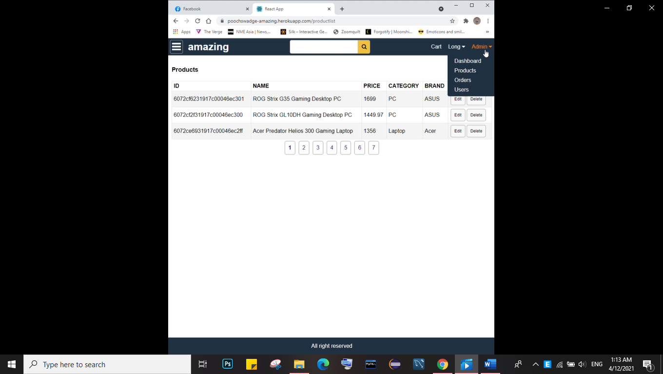

An example of a product list is shown below.

**NB.** Availability information will be available for registered admins only.

The following additional information about the searched for product may also be available.

* COFA – Certificate of Analysis – An ASP page generated from the Amazing website.
* MSDS – Material Safety Data Sheet – An ASP page generated from the Amazing website. (where

applicable)

* Detailed information on this product – From the Amazing website or from partner website

**2.2** **Register for Amazing**

To register for Amazing Adminu\istrator select the *Sign-in*  option in the top right hand box.

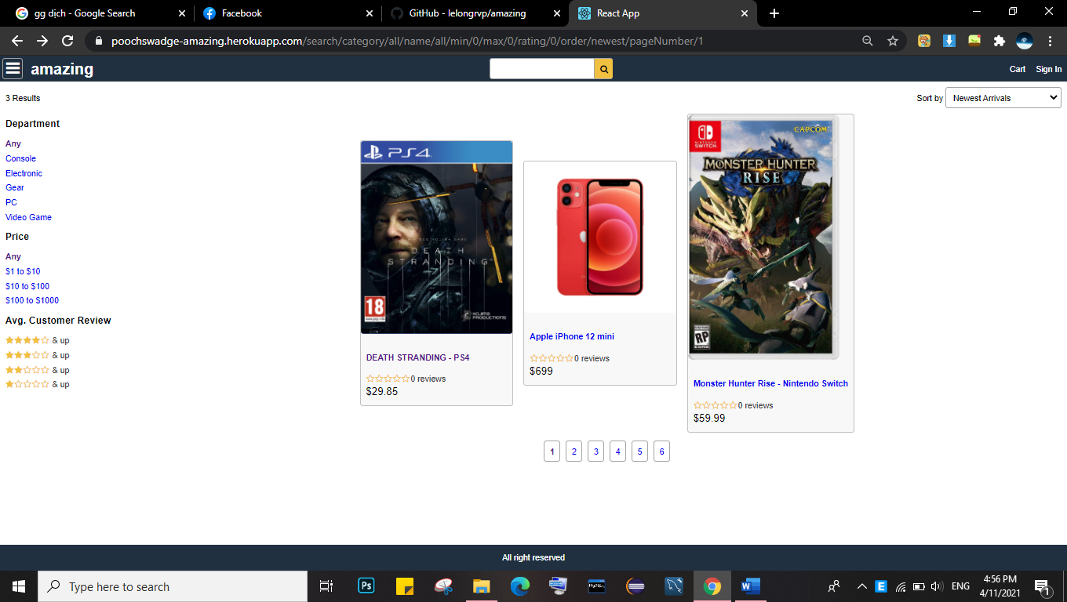

This will take you to the online registration form.

Admins are asked to complete this form (all fields marked with a * are mandatory) and click *Ok.*

**NB**. It is recommended that new **users do not use their email address** as their ‘User ID’ as this cancause some issues.

**3** **Products :**

Once you have been validated by the system, you will see a screen as below:

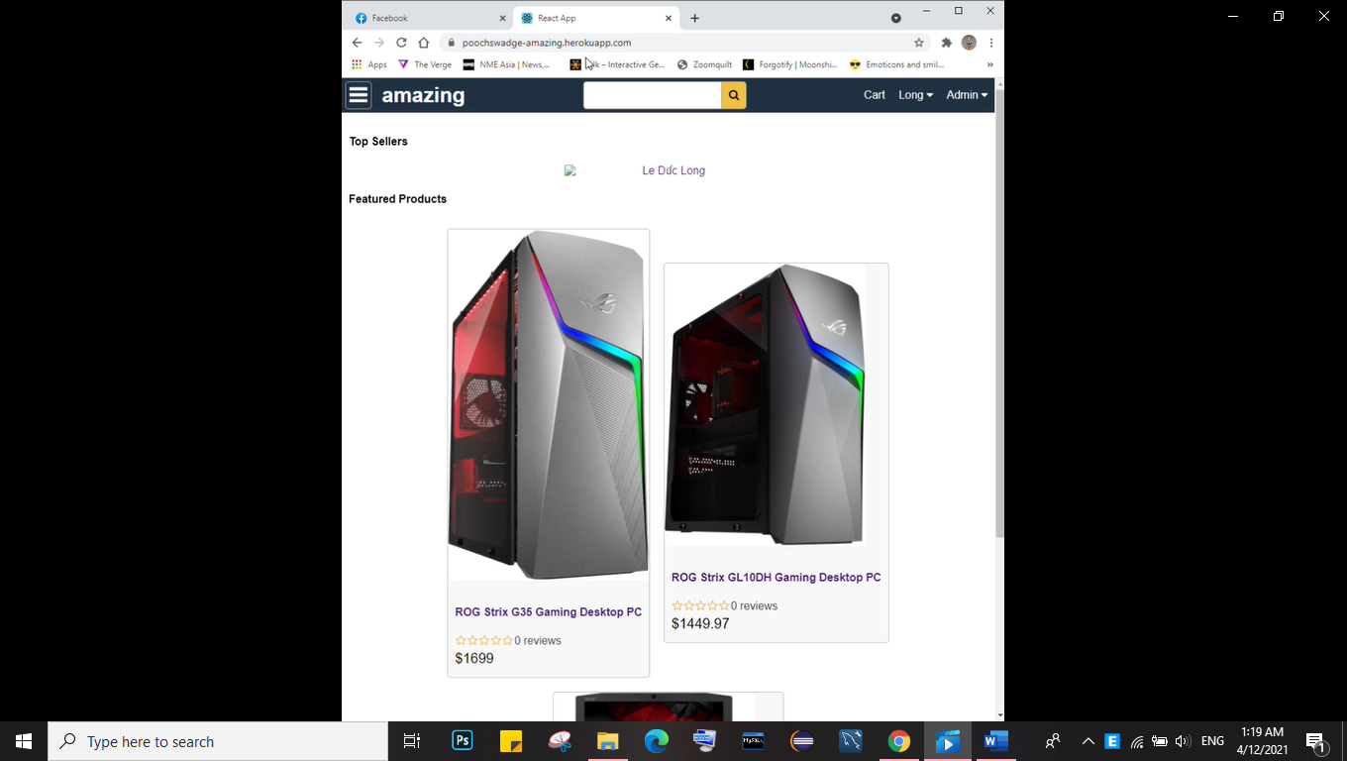

**3.1** **Adding items :**

This is the most important feature for admin to adding a new items.

Selecting this option will bring you to the following screen.

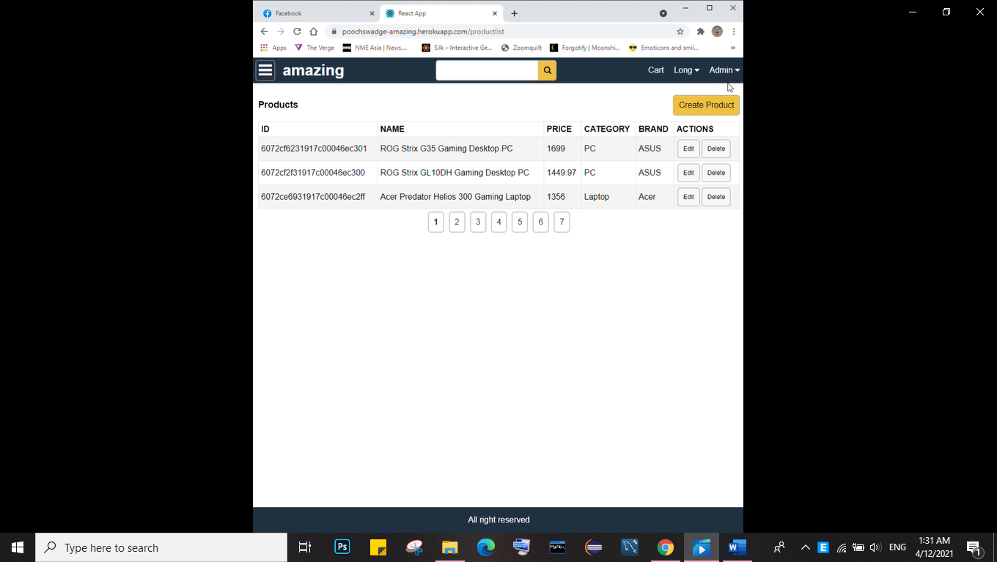

Click *Create Product.*

Locate the product you wish to order (ID, Name, Price, Category, Brand, Actions)

Enter the quantity and click Save*.*

You can edit or remove the product by pressing the Edit button or Remove button

**4** **My Order List**

Selecting the *My Order List* allows users to view the following.

**Past Orders**

This screen shows all the past orders.

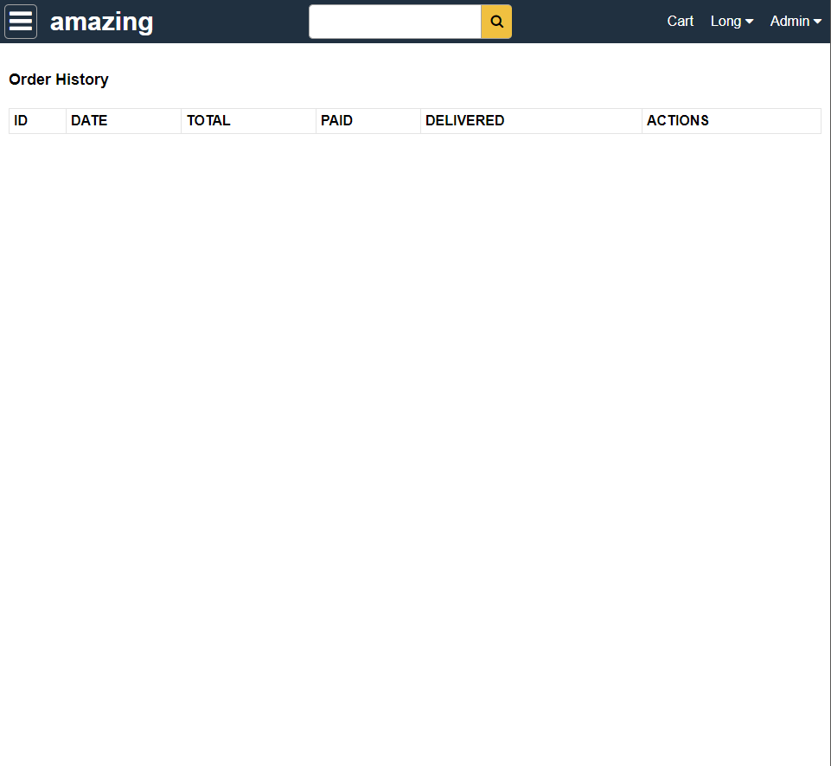

You can filter the past orders using ID, Order Date Range, Time Deliveried or Customer’s reference. You can also view the order by clicking the order number link of any order or invoice details by clicking on the invoice number link.

**5** **Edit Admin Profile**

You can edit your Profile by selecting the *Edit Profile* button in the box on the left hand side of the screen.

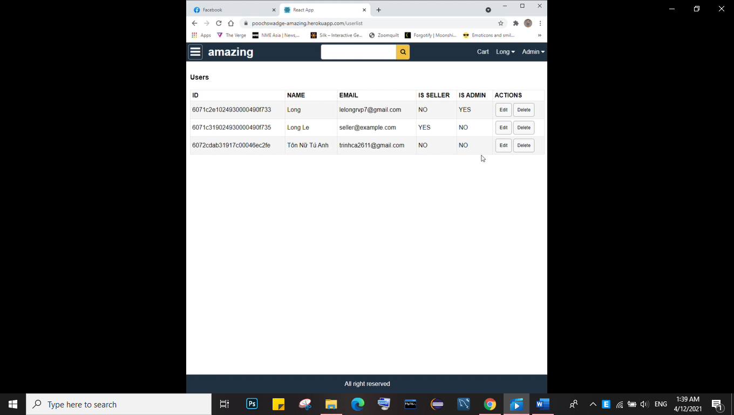

This will display your user details as per below and allow you to make any necessary updates. Once you are happy with your updates, click *Update.*

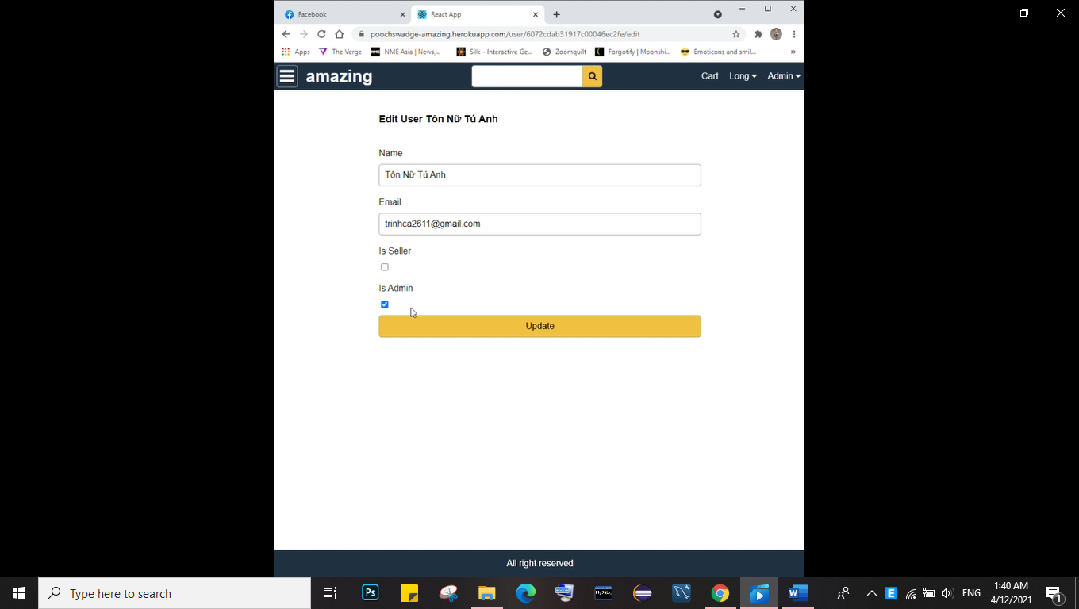

|  |  |  |
| --- | --- | --- |
| **Tips for creating a good password** | **Examples** |  |
|  |  |  |
|  | pag4ks |  |
|  | passwords are |  |
| Use the first letters of a phrase you like, then add a number, punctuation | good for K-State |  |
| mark, or uppercase letter in the middle. Even better is an obscure phrase | pag4mt |  |
| or line from a favorite song, book, movie, or poem. In your phrase, replace | passwords are |  |
| words with numbers or letters (be=B, to=2, too=2, for=4, are=R, see=C, | good for me too |  |
| you=U, why=Y). | pag4m2 |  |
|  | passwords are |  |
|  | good for me too |  |
|  |  |  |
|  | pagb7in |  |
|  | passwords are |  |
| Include numbers. Put one or more numbers in the middle of the password. | good but 7 is not |  |
| Or use three or more numbers at the beginning or end. Or use all numbers. | pagbn200 |  |
|  | passwords are |  |
|  | good but not 200 |  |
|  |  |  |
|  | pagfm? |  |
| Use punctuation marks. A question mark or exclamation mark can add | passwords are |  |
| emphasis to a password phrase you've chosen. You can use any of the | good for me? |  |
| basic punctuation marks on a keyboard: | pag,rtn? |  |
| !@#$%^&*()_+-={}|[]\:";'<>?,./ | passwords are |  |
|  | good, are they not? |  |
|  |  |  |
|  | paGfm2 |  |
| Mix uppercase and lowercase letters. | passwords are |  |
|  | GOOD for me too |  |
|  |  |  |
| Reverse part of a word or phrase to make a nonsense word. Then add a | paS-drow |  |
| number, punctuation mark, or uppercase letter in the middle. |  |
|  |  |
|  |  |  |

**Things you shouldn't use for passwords**

* Don't use building names and codes and all kinds of sports jargon.
* Don't use the first or last names
* Don't use your personal numbers (age, phone number, postal address) or ID codes (date of birth,

driver's license, IC). Those numbers are more public than you think, especially with search engines and the Web.

* Don't include any known information about you, such as parts of your computing ID, name, address, pet names, friends' names, family names, hobbies, or favorites.
* Don't use well-known phrases like "gwtw" (Gone With the Wind) or "2brnot2b" (to be or not to be).
* Don't use obvious number sequences such as "123456" or "8765432".
* Don't use a real word, whether English, foreign, medical, sci-fi, etc.